FUNDS MANAGEMENT

BUSINESS BLUEPRINT

Submitted to

Dungsam Cement Corporation Limited





By



Wipro Ltd.
October 2012
Version 2.0

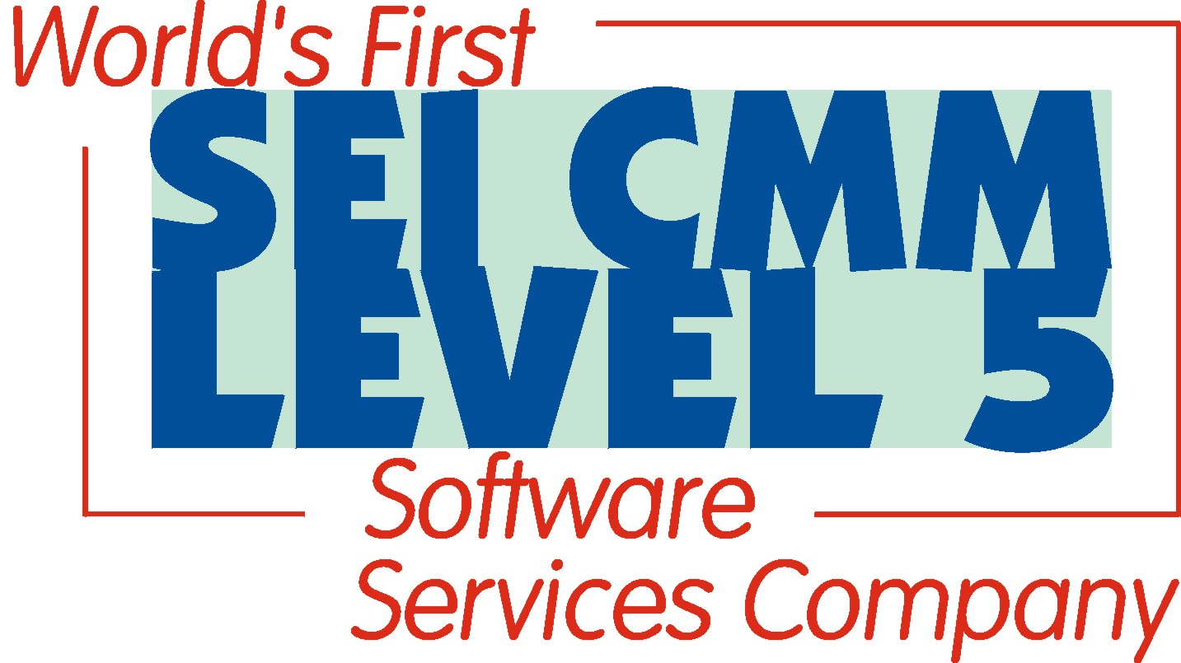

DOCUMENT APPROVALS

Sr. No | Details | Name | Signature/Date
1 | Prepared By | Kiran Kumar G  (Wipro FICO Lead Consultant)
2 | Reviewed By | Parul Karan Bhasin  (Wipro Project Manager)
3 | Reviewed By | Dorji Zangmo  (DCCL CTM)
4 | Reviewed & Approved By | Dechen  (DCCL CTM)
5 | Reviewed & Approved By | Sangay Tshering  (DCCL CTM)
6 | Reviewed & Approved By | DrugayRana  (Project Manager)
7 | Reviewed & Approved By | Pema Tshering  (Head – ICT, DHI)
8 | Reviewed & Approved By | Tshering Tenzin  (Project Director)

DOCUMENT INFORMATION

Project Name | Document Name | Document Location
iDragon | Funds Management Business Blueprint | Document Server

DOCUMENT HISTORY

Version | Document Name | Date | Authors | Reviewed By | Change Control
1.0 | iDragon_BBP_DCCL_FM_V1.0 | 12.09.2012 | Kiran Kumar G | Parul Karan Bhasin | Initial version
2.0 | iDragon_BBP_DCCL_FM_V2.0 | 28.09.2012 | Kiran Kumar G | Parul Karan Bhasin | Final version

TABLE OF CONTENTS
1 EXECUTIVE SUMMARY 6
1.1 Background of DCCL 6
1.2 Business Blueprint Overview 6
1.3 Funds Management 7
1.4 Modules Integration 8
2 ORGANISATION STRUCTURE 12
2.1 Maintain FM Area 12
2.2 Assign Company code to FM Area 12
2.3 Assign Fiscal Year variant to FM Area 12
2.4 Activate BCS-Budget Control System 13
3 MASTER DATA 14
3.1 Create Hierarchy Variant – Fund Center 15
3.2 Assign Hierarchy Variant to FM Area 15
3.3 Create Fund Center 16
3.4 Create Commitment Item 16
3.5 Commitment Item Category 17
3.6 Financial Transaction 18
4 BCS SETUP – BUDGETING 19
4.1 Activate Account Assignment Elements in BCS 21
4.2 Define Budget Category 22
4.3 Define Budget Type 23
4.4 Define Budget Type Groups 23
4.5 Define Document Types 24
5 BCS – AVC 25
5.1 Tolerance Profile 26
5.2 Filter Settings for Budget Values 28
5.3 Filter Settings for Commitment / Actual Values 29
5.4 Derivation Strategy 30
5.5 Select Checking Horizon for Availability Control 31
5.6 Activation of Availability Control 32
6 COMMITMENT UPDATES AND INTEGRATION 33
6.1 Update Profile 33
6.1.1 Assign Update Profile to FM Area 35
6.2 Override Update Profile 36
6.3 Make Other Settings 36
6.4 Maintain Number Range for FM Area 36
6.4.1 Assign Number Range to FM Area 37
6.5 Activate / Deactivate Funds Management 37
7 CLOSING OPERATIONS 38
7.1 Commitment Item Carry Forward Payment Budget 40
7.2 BCS - Activate Budget Carry Forward for Commitment 40

Abbreviations and Acronyms.

The following abbreviations and acronyms have been used in this document:
Abbreviation/Acronym | Description
DCCL | Dungsam Cement Corporation Limited
AA | Asset Accounting
AP | Accounts Payable
AR | Accounts Receivable
AUC | Asset under Construction
BBP | Business Blueprint Process
CO | Controlling
COA | Chart Of Account
CSBP | Current State Business Process
CWIP | Capital Work In Progress
DMS | Document Management System
FI | Financial Accounting
FRICE | Format, Reports, Interface, Configuration & Enhancement
FSBP | Future State Business Process
G/L or GL. | General Ledger
GR | Goods Receipt
IM | Investment Management
IR | Invoice Receipts
JV | Journal Voucher
MAP | Moving Average Price
MM | Material Management
PM | Plant Maintenance
PO | Purchase Order
PS | Project System
SAP | System, Applications and Products in Data Processing
SD | Sales and Distribution
BCS | Budget Control System
T-Code | Transaction Code
BAC | Budget & Availability Control
WBS | Work Breakdown Structure

EXECUTIVE SUMMARY

Background of DCCL

Dungsam Cement Project (DCP) was initiated by the Royal Government of Bhutan in 1982 with assistance from Government of India.
DCP was incorporated as Dungsam Cement Corporation Limited (DCCL) on 9th September 2009 under the Companies Act 2000 of the Kingdom of Bhutan as a wholly owned subsidiary of Druk Holdings & Investments (DHI). DHI was established as holding and investment arm of the Royal Government of Bhutan through a Royal Charter in November 2007.
DCCL is currently in the process of setting up a new, integrated, Greenfield cement project with a production capacity of 1.0 million tonnes of clinker and 1.36 million tonnes of cement per year. The total cost of the project is Nu. 9,511 million. The project is located at Chengkari, Nganglam, Pemagatshel Dzongkhag in eastern Bhutan at an approximate distance of about 150 km from Guwahati, Assam, India.
The project is in an advanced stage of its implementation and is expected to be commercially operational in the initial months of the year 2013.

Business Blueprint Overview

A Business Blueprint documents the business process requirements of a company. The Business Blueprint gives a general idea of how business processes could be mapped in one or more SAP Systems. The Business Blueprint documents in detail the scope of business scenarios, business processes, process steps, and the requirements of SAP solution implementation.

The purpose of this document is to present a comprehensive Business Blueprint document for FM Module. This document also summarizes the findings of the Wipro consulting team and DCCL team, with respect to SAP processes to be implemented at DCCL. On completion of the blueprint, the consultants will determine the SAP functionality required to run the DCCL business. The Blueprint presents a summarized perspective of functional business processes that will be implemented.

The information gathered and documented in the Blueprint are sufficient for the team to go forward into the Realization phase. However, it is critical that both the Consultants and DCCL team agree on the scope of the project as presented in this document. Acceptance - by both teams - is required to move the project into the next phase.

Objective of this document:

- To identify and document the configuration values applicable FSBP-wise post discussion with CTMs.
- Have one comprehensive document with reference to capturing of Gaps and FRICE requirements.
- Brief about the module’s standard functionalities, its integration with other modules, master data requirements and relevant organization structure.

Funds Management

The purpose of Funds Management is to budget all expenditures for individual areas of responsibility, to control future funds transactions in accordance with the distributed budget, and to stop the budget from being exceeded. Funds management provides features of releases, supplements, returns, and transfers.

Funds Management enables;

- Budgets all expenditures for individual responsibility areas.
- Monitors funds movements in the light of budget available.
- Prevents budget over-runs.
- Online active availability control – warning and/or work flow for insufficient funds, error in case of over consumption etc.
- Budget utilization and monitoring is well defined and transparent.
- Integrates with all other SAP Modules.
- Budgetary control and reporting through the system.

Funds Management -Budgeting

The Funds Management Module provides a single platform for viewing the consolidation of all the budgets (Materials Budget, Manpower Budget, Expense Budget, Site Budget, Depreciation Budget, Interest Budget, Capital Expenditure Budget, Inventory & other asset and liability budget) they need to be feeded into the Funds Management Module in SAP .

These figures need to be feeded by a combination of Funds Center and Commitment Item (the details of which are laid down in detail down below)

Once this is done DCCL can monitor the funds movement based on the budget available and prevent budget overruns. DCCL would incorporate all the features of the Funds Management Module namely:

- Budget Structuring

- Budget Execution

- Integration with other Modules

Budget Structure:
The functions in this component support you in creating budgets. The budget is allocated according to a defined budget profile and a budget version. The budget structure only contains the elements that are needed in your organization for budgeting from all possible combinations of funds centres and commitment items. Only combinations of funds centres and commitment items that can be budgeted appear in the budget hierarchy. This helps the funds centre manager save time in budgeting. (Discussed in detail later)

Budget Execution:
The Budget Execution component helps you prevent budget overruns. You can set a warning, error message or a workflow to the Fund Manager depending on the percentage of the budget utilised. This is the most important feature in the Funds Management Module. Since DCCL may also change the budget by increasing the budget or transferring the budget of respective fund centre, the budget execution sub module also provides for that facility.

Modules Integration

Features to DCCL business;

DCCL would like to control effectively their monthly budget through SAP_BCS. SAP_BCS is more flexible tool to control different checks against DCCL’s requirements. It can be possible to control capital expenditure / revenue expenditure budget through BCS.

Standard operating purpose:

  - Business must upload budget / planned figures in SAP against their fund centre/Commitment Item.
  - Release the budget
  - Manually enter the supplement budget, if required after proper approval
  - System automatically control actual figures would not exceeding the budget /planned figures.
  - System also give warning message if budget consumed more than 90%
  - SAP facilities several standard reports for getting actual values / budgeted values.
  - Committed budget can be carried forward to next fiscal year if required.
Funds Management provides excellent integration with other modules for actual reporting and commitment reporting. The transactions from other modules which need to be tracked are to be identified by DCCL. Example the movement types in Materials Management, the transactions in Production Planning, the FI document types and Asset transactions. Once this is done actual and commitment data will flow automatically into Funds Management module. DCCL will be taking advantage of this feature for their budget controlling with respect to actuals and commitments.(Discussed in detail later)

Financial Accounting

All business transactions posted in Financial Accounting are recorded in Funds Management too. You post these business transactions in the Accounts Receivable, Accounts Payable, and General Ledger menus.

Example:
- G/L accounting
G/L account posting, posting of parked documents, settlement cancellation, incoming payments, outgoing payments
- Accounts payable accounting
Invoices, credit memos, down payments, internal transfers, incoming payments, outgoing payments
- Accounts receivable accounting
Invoices, credit memos, down payments, internal transfers, incoming payments, outgoing payments.
When you post a value here, the commitment item specified in the G/L accounts is proposed. You can use this, or overwrite it with another commitment item. If you have not defined a commitment item in the G/L account, you must enter a commitment item manually.

When you post, the system creates a document for Financial Accounting. In Funds Management, the system only creates line items online for the FI line items for which you specified a commitment item with financial transaction 30 when posting.
If you specify a funds center when creating the commitment item master data for the respective item, this is also displayed as the default value during posting. In the same way, you can specify a fund when creating your funds centers which then appears as the default value during posting and which can be overwritten.

Materials Management (MM):

In Material Management Module you can choose the movement types you want to be updated in the Funds Management. Once this is done the actual and commitment values will flow into Funds Management.

An important point to be noted is that all values before invoicing fall under commitment values, the rest fall under actual values. Example of a commitment could be a purchase order and an actual is an invoice.

Examples of Materials Management transactions which could be brought into Funds Management are:

- Purchasing

Purchase requisition, purchase order.

- Inventory management

Goods receipt, goods issue, transfer

- Invoice verification

Invoice receipt, logistics invoice verification

Plant Maintenance
Integration between the Plant Maintenance (PM) and Funds Management (FM) components enables to monitor budget-relevant plant maintenance processes in FM.
The link between the plant maintenance process and FM is established by entering an FM account assignment (commitment item, funds center) at the time of creation of maintenance order. In DCCL, the FM account assignment will be derived automatically from the maintenance order during subsequent processes triggered automatically by the maintenance order, such as purchase requisitions.
The FM account assignment is derived automatically. If however, the assignments of FM account assignments to CO account assignments are also maintained, the system determines the FM account assignment from the cost elements, which is assigned to the main work centre of the maintenance order.

Asset Accounting:
The following business transactions posted in Asset Accounting can be passed on to Funds Management:
  - Acquisitions
  - Postings during the construction phase
  - Postings while the asset is in use
  - Retirements
The transaction types that are relevant to depreciation are not updated in the standard system because these do not affect expenditure.
If a cost center or a CO order is defined in the asset master record, the system uses the funds center and fund assigned to this cost center or order as the default account assignment for the FI document.

ORGANISATION STRUCTURE

Maintain FM Area

A Financial Management Area (FM) is the highest organizational unit within Funds Management. A Financial Management area is assigned to the Company Code and the Controlling Area in order to be able to carry out budget planning and execution. Funds Management is used for budgetary control purposes. The FM area is taken from the company code when a company code is assigned to a FM area. More than one company code can be assigned to an FM area.

For DCCL F.M area will be FMDC.

Assign Company code to FM Area

A Company Code represents an independent legal accounting entity in SAP. Balance Sheets and Profit/Loss statements required will be created at the Company Code level. In other words, a company code is an organizational unit for which a complete self-contained set of accounts can be drawn up for external reporting purpose. In order to be able to carry out budget planning and execution, fund management must be assign to the respective company code. The FM area is taken from the company code during the assignment of a company code to FM area. More than one company code can be assigned to FM area.

 |  | Company Code |  |  | Fund Management Area
 |  | DC01 |  |  | FMDC
 | Assign Fiscal Year variant to FM Area

Here, fiscal year variant is assigned to FM area. Different fiscal year variants can be assigned for Funds Management from that of Cash Budget Management and/or Financial Accounting

If fiscal year variants are used with special periods, the variants in Funds Management and Financial Accounting must match. Otherwise the FI postings in a special period are transferred to the period of the posting date and not to the special period in Funds Management. Since DC01 has been assigned fiscal year variant K4 in FI, the same fiscal year variant will also be assigned to the F.M area.

Fund Management Area | Fiscal Year variant
FMDC | K4
The Company code and the FM Area will now have a same fiscal year variant available to control posting periods as needed.

Activate BCS-Budget Control System

Activate the Budget Control System (BCS) as an operative budgeting tool of the component Funds Management Government. Define a from-fiscal year for an FM area for this purpose.

Activation of the Budget Control System will have an effect on the following Funds Management functions:

Fiscal year change-

The carry forward of budget for commitments is only supported for the budget entered in the Budget Control System.

Budgetary ledger-

If there is the use of budgetary ledger, only the budget postings that were entered in the budget control system are updated in the budgetary ledger.

Availability control of former budgeting-

The FB availability control is deactivated by default when the budget control system is activated.

If the Budget Control System is to be implemented as an operative budgeting tool, define a from-fiscal year for FM area.

Fund Management Area | From Fiscal Year
FMDC | 2012

Budget preparation flow

The below flow chart explains the Budget preparation flow in DCCL.

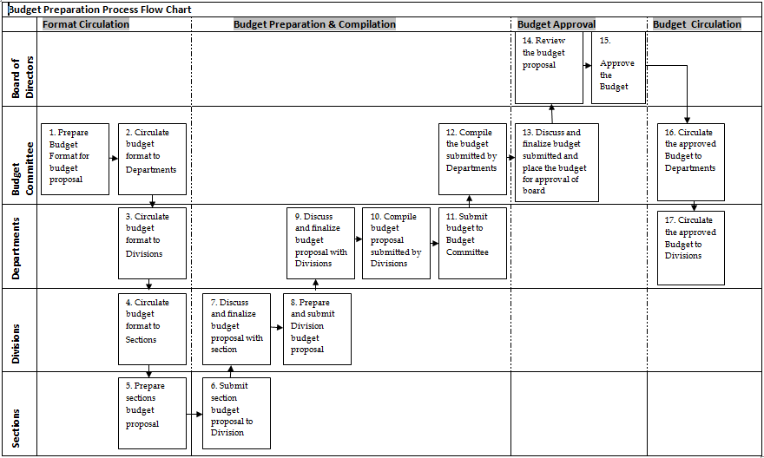

MASTER DATA

There are two master data elements in Funds Management, namely Commitment Items and Fund Center as detailed below:

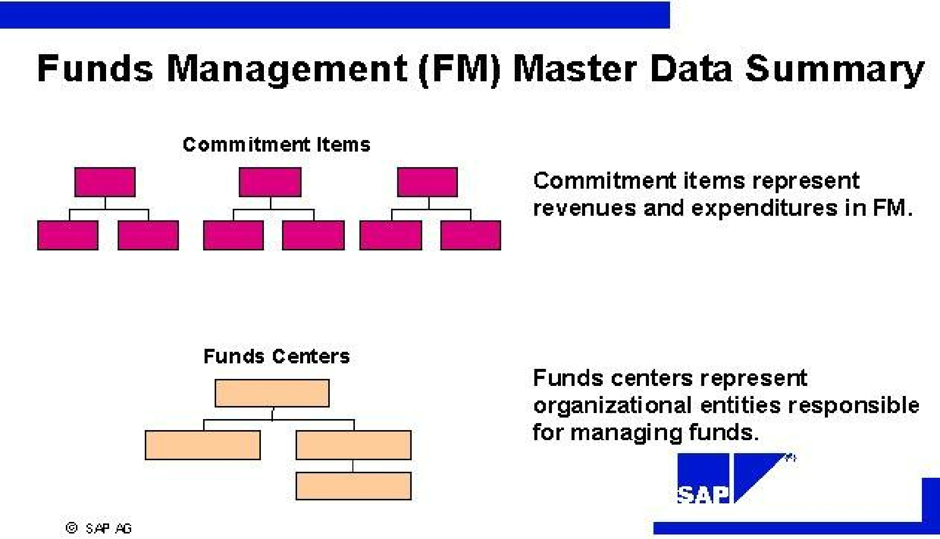

Create Hierarchy Variant – Fund Center

Hierarchy Variant will enable to create a hierarchical relationship with funds canters.

A fund centre hierarchy is displayed in a hierarchy variant in the system by following the steps as below,

- Create a hierarchy variant.

- In master data maintenance, maintain the hierarchical relationship between funds centers of an FM area in the hierarchy variant.

Hierarchy variants are year-independent. In assigning a hierarchy variant to an FM area/fiscal year, we determine the current valid fund centre hierarchy of a FM area.

Hierarchy variant 0000 will be used for DCCL.

Field Name | Value
Hierarchy Variant | 0000

Assign Hierarchy Variant to FM Area

Here, determine which hierarchy variants are to be assigned to the FM area and fiscal year as the current valid funds center hierarchy.

Fund centers in Funds Management are arranged in hierarchies. One fund center hierarchy per FM area can be defined.

If working in year dependent FM area, then respective fiscal year must be entered. To work in year independent FM area, make "0000" as the entry for the fiscal year.

F.M Area | Fiscal Year | Hierarchy Variant
FMDC | Blank | 0000

Hierarchy variant is assigned to the F.M Area.

Create Fund Center

SAP defines the Funds Center as an organizational unit within the Funds Management (FM) module. It represents the lowest level area of responsibility for budgetary monitoring and controlling costs by area of responsibility.

Budget is assigned to funds center. Budget is used up as postings are made to funds center, giving rise to commitment and actual values.

Following are the Fund Centers identified for DCCL.

FC Code | DCCL
NGL_COR | Corporate
NGL_FIA | Finance & Accounts
NGL_HRA | Human Resources & Admin
NGL_SDM | Sales & Marketing
NGL_PRC | Procurement
NGL_ICT | ICT
NGL_OPR | Operations
NGL_MNT | Maintainence
NGL_QLY | Quality
NGL_MNS | Mines
NGL_OHS | Occupational, Health, Safty & Environment
NGL_MMT | Material management
NGL_PJT | Projects
GPG_DPO | Depo-Gelephug
PLG_DPO | Depo-Phuntsholing

Create Commitment Item

Commitment items represent budget classifications of revenues and expenditures in the Funds management module. Commitment items are mapped to the GL account in FI and to the revenue and cost elements in CO. Before creating a GL account, a commitment item needs to be created first as the commitment item field in GL master record will be made mandatory in order to keep the modules in sync.

This is an organizational structure and business can upload the budget or planned values in to commitment items. It is not possible to upload any budget figures without commitment item. For DCCL , every budgeted expense GL account are same as Commitment item , however, business can also create commitment items for non budgeted GL accounts and budgeted GL accounts with different financial transaction type & commitment item category.

Each GL account will be mapped to a commitment item (one-to-one) or can map group of GL accounts to one Commitment item (option open for DCCL). The commitment item number will be the same as that of the GL account number. The system will derive the commitment item automatically from the GL account, for any direct or automatic GL posting (Automatic postings update the GL from sub-ledger accounts). Commitment items in Funds Management are arranged in hierarchies. More than one hierarchy can be created for an FM area
Attached Excel contains the list of commitment items at this point of time and kept open for future purpose.
Error! Not a valid link.

Commitment Item Category

The commitment item category is used for differentiating commitment and actual values from other components as well as differentiating budget values in revenues and expenditures. These are documented accordingly in the FM information system.

More than one or more commitment item hierarchies for each commitment item category can be created. The commitment item category is identical in all commitment items within a hierarchy.

When creating a commitment item within a commitment item hierarchy, the system automatically copies the item category of the superior commitment item.

The item category can only be changed as long as no budget values or actual values were posted to the commitment item and can only change the item category in the master record of the top commitment item of a commitment item category. The system then automatically copies the change for subordinate commitment items.

Commitment item category can be freely defined for commitment items not assigned to any commitment item hierarchy.

Item Category | Description
1 | Balance
2 | Revenues
3 | Expenditures

Financial Transaction

Financial Transaction is control parameter of commitment item master record. It is technical business transaction. It is centrally recording actual and commitments in FM and cash managements. In SAP, there are some predefined financial transactions which can be utilized for specific business transactions. Like 30 for post invoices and revenues, 40 for goods receipt and goods issue, etc.

Financial
Transaction
Transaction | Description
30 | Post Revenue, Expenditure, Asset, Inventory stocks
40 | Post GR/IR
50 | Clearing
60 | Post Receivables and Payables from goods and services
70 | Post Customer Clearing
80 | Post Bank clearing
90 | Bank, Cash

For DCCL business, there are 6 types of financial transactions and 3 type of commitment item category are proposed. Budgeted commitment items: Financial transaction type: 30 & Commitment item category is 3. In case of non-budgeted commitment items, financial transaction type is 50 & commitment item category is 2, and etc.

 | Account |  | Financial |  | Item Category
 |  |  | Transaction
 | P/L Expense |  | 30 |  | 3
 | Stock/Inventory Items |  | 30 |  | 3
 | Asset |  | 30 |  | 3
 | GR/IR |  | 40 |  | 3
 | Bank/Cash |  | 90 |  | 1
 | Receivables |  | 60 |  | 2
 | Payables |  | 60 |  | 3
 | Input tax |  | 30 |  | 2
 | Output tax |  | 30 |  | 3
 | Other Non Budgeted GL |  | 50 |  | 3

Link between Basis Data Elements in other Components.

Define a commitment item in the G/L account in the posting transaction; the system derives the commitment item from the G/L account.

Assignment of a commitment item to a CO account assignment in the posting transaction, the system derives the commitment item from the CO account assignment.

BCS SETUP – BUDGETING

This component includes all settings and functions in the budget control system that is necessary for processing budget data. The functions include entering budget data, updating the budget.

BCS budgeting is like other components of the budget control system in that the customer-specific adjustments can be combined with those settings delivered by SAP.

Integration

If a budget structure have been defined and activated the check on budget addresses, only this selection of FM account assignments can be budgeted in BCS budgeting.

If working with budget types, the only ones that are updated in the BCS availability control are those that are defined as consumable budget in the AVC filter settings.

Features

Budget entry document

Processing budget data is logged in budget entry documents. Budget entry documents can be created in Mass Processing – for example when transferring data from plan data – or created selectively in individual processing.

Budgeting process

To differentiate between the respective budget processes, an entry document is characterized by its budgeting process. The budgeting processes delivered by SAP can be supplemented with different customer-specific budget types in order to subdivide further.

Status management

Status management enables to subdivide the budget planning and budget execution of a fiscal year into different budgeting phases. This regulates the permitted budget processes for specific points of time in the fiscal year.

Consistency check

The check rules managed in the check libraries regulate whether a budget value posting is allowed or not in BCS budgeting. These consistency checks can be defined according to customer-specific perspectives.

Budget approval

Budget entry documents that are saved as pre posted documents undergo an approval procedure. Start the budget approval in combination with specifically definable document types by using a workflow.

Posting a budget supplement

- Create this budget update in the budgeting workbench by creating a budget entry document with the process Supplement.

- To save the entry document, use either Hold, Prepost or Post. Whilst held documents are saved locally at work center, preposted or posted documents are saved in the database instead. In this example, the budget supplement is preposted.

There are a number of checks when we want to save entry documents:

- There is a check in the status management on whether the process supplement is permitted in the current permitted status (in example status 1). There is also a check on whether the respective processor has authorization in status 1.

- The activated check rules are run one after the other with the consistency check.

- The preposted supplement is saved in the database after a successful check, but still undergoes an approval procedure.

The budget amount is posted with the approval of the supplement. The status of the entry document changes when this happens from Preposted to Posted.

Activate Account Assignment Elements in BCS

We define which account assignment elements should be used in the budget control system (BCS). At the time of activation of BCS, it is defined that the input field of an account assignment element is available in BCS budgeting transactions.

The following statuses will be defined for DCCL for activating or deactivating the account assignment elements:

Not Used

The account assignment element is not active for budgeting. The input field of the account assignment element is not displayed in the budgeting transactions.

Optional

The account assignment element is activated for budgeting. The input field of the account assignment element is ready for input as an optional field entry in the budgeting transactions. Initial is also a possible entry value.

Mandatory

The account assignment element is activated for budgeting. The input field of the account assignment element is a required entry field.

The following account assignment elements are available:

Funds center

Commitment item

Fund

Functional area

Grant

Funded program

Note:

Although the settings that can be defined here are somewhat more flexible than the other Funds management customizing settings, the settings of the BCS budgeting defined here must take the other Funds management settings into account.

Account assignment elements that are not activated in Funds Management cannot be activated in the BCS budgeting. The status Not Used should be set for these account assignment elements. More information on activating account assignment elements can be found under "Activate Account Assignment Elements".

Account assignment elements that have the input value initial (blank) in Funds Management cannot be set with status Mandatory in BCS

The account assignment elements "funds center" and "commitment item" are generally activated as mandatory entry fields in Funds Management and it cannot be changed.

The status of the account assignment elements for each FM area can be defined according to the requirements.

Define Budget Category

Here, the budget categories are determined to be used for an FM area in the organization.

The number of years or time horizon that should be used for budgeting for each budget category can be defined. The year of cash affectivity and whether the time horizon should start from the following year or not are also defined.

Example

We want to use the commitment budget with the following values:
- Time horizon three years
- Indicator set for the start of the time horizon from the next year

When using budget categories, the following ledgers are available:

- 9F for the Payment Budget
- 9G for the Commitment Budget
- 9J for the Financial Budget.

Here, the 9F ledger will be used for Payment Budget-

FM Area | Budget Category | Time Horizon | Start Next Year
FMDC | Payment (9F) | <leave blank> | unchecked

Define Budget Type

Here, define the BCS budget types that are to be used in the organization. When setting up the budgeting procedures, several budget types can be defined for the organization. The combination of budget type and budgeting process represents a customer-specific definition of budget values.

To do this, carry out the following activities:

- Define budget types.

- Assign one or more budgeting processes to each budget type.

Below is the list of the budget types-

Budget Type | Description | Description (M) | Description (L)
A1 | A1 | Budget Adjustment | Budget Adjustment
BI | BI | Budget Initial | Budget Initial
CF | CF | Carried Forward | Carried Forward
PR | PR | Preparation | Preparation

Define Budget Type Groups

We can bundle different budget types in a budget type group. Budget type groups enable to define multiple budget types to be used for consumption.

Below is the list of the budget type group-

FM Area | Budget Type Group | Description
FMDC | CY | Current Year Budget
FMDC | PY | Prior Year Budget

In the budget type groups, maintain the budget type as below-

Budget Type Group | Budget Type
CY | A1
CY | BI
CY | CF
CY | PR
PY | CF

Define Document Types

Here, define the document types that are to be used for budget postings in Funds Management. Different document types can be used to classify the budget entry documents. By using different document types, it is possible to classify budget entry documents according to the user-specific criteria, by assigning meaningful names to the individual document types used within the organization.

Using the document type, it is also possible to control the scenario to be supported within an entry document. We can choose between the following scenarios:

- Budget only - only budgeted amounts are contained in the entry document.

- Release only - only released amounts are contained in the entry document.

- Budget with automatic release - we can restrict the entry document to specific budgeting processes: enter, return, supplement, and transfer. In the specific case of a transfer process (send / receive), the following applies:

o If the sender side is chosen, only released budget can be transferred. Budget will be updated on the receiver side.

o If the receiver side is chosen, only unreleased budget can be transferred. Budget will be released on the receiver side.

- Statistical only - only statistical values are contained in the entry document.

Below is the detail of the document type-
Doc Type | Text | Scenario for Value Type
BADJ | Budget Adjustment | Budget
BCFW | Budget C/Fwd | Budget
BENT | Budget Entry | Budget

BCS – AVC

Using the AVC component, the availability of funds can be monitored in the Budget Control System of Funds Management.
Availability control and BCS budgeting are flexible tools that can be used to check consumable budget (budget or releases) against consumed amounts (commitment or actual postings) within a budget process. If budget consumption reaches one of the tolerance limits specified in customizing, this can trigger system activities, for example, additional postings are prevented.
Overview of Availability Control Functionality

Using BCS availability control can:
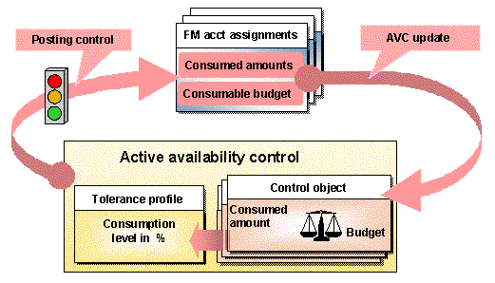

- Define the budget values or releases to be used to cover budget consumption.

- Set activity-specific tolerance limits.

- Define availability control objects, for which a check can be carried out of the updated and summarized budget, commitment and actual postings in Funds Management.

- Carry out multi-level activation of availability control procedures.

- Use of a number of availability controls implemented in parallel

Availability control checks the Funds Management posting procedures and the posting data of the integrated components (FI, CO, MM and so on) updated in Funds Management

In the availability control ledgers, the account assignment-related updating and summarization of the complete consumable budget are checked against the consumed amounts. This is carried out at the control object level.

If working with releases or with different budget types in the organization, we can define which budget entered in the FM account assignments (or budget addresses) is made available as consumable budget in the control objects. It can also be specified which commitment and actual postings update the availability control ledgers as consumed amounts.

All posting procedures updated and checked in the availability control ledger are classified according to an activity group. Activity groups subdivide postings according to specific posting procedures. This is specified in customizing, where activity groups are defined and their assignment to posting transactions. Different tolerance limits per activity group can be combined into a single tolerance profile.

The check of the posting data updated in AVC and the definition of the consumable budget takes place at the level of the availability control objects. The summarization of FM posting data and of budget data are defined at the level of the AVC control objects in a derivation strategy.

BCS availability control cannot be used as a replacement for the availability control in former budgeting. If former budgeting is used for budgeting in Funds Management and not BCS, then implement availability control for former budgeting must be used.

Tolerance Profile

Here, define the tolerance profile for the active availability control in the budgeting of Funds Management (FM).

For each tolerance profile, define whether to work only with percentage usage rates or also with maximum permissible absolute differences. If absolute variance as tolerance limits is to be allowed, then it is must to assign a currency to the tolerance profile - this currency must match with FM area currency.

In a tolerance profile, group together the tolerance limits for the different activity groups. One or more tolerance limits can be defined for each activity group by specifying different usage rates or also absolute variances. Also define the check sequence of the different tolerance limits. Assign a message type to each of these defined check events. As message type, an error message, a warning, or information can be issued.

Ceiling Type-
Ceiling type can be used to control whether the availability control should limit expenditures from bottom to top.

Normally, the availability control checks only expenditures (for example, outgoing payments).
Example

The tolerance limits of the availability control for actual postings (activity group 40) could, for example, be defined in a tolerance profile such as this for example

Activity Group | Sequence | Message Type | Usage rate
40 | 01 | Information | 70%
40 | 02 | Warning | 85%
40 | 03 | Error Message | 100%

Here, we will create tolerance profile as below-

Tolerance Profile | Description | Currency | Category of Tolerance Profile
DCCL | User Warnings Only | BTN | Only Usage rates are allowed

And will make the further setting as below-

Field Name | User Action and Values
Ceiling Type | Outgoings
Activity group | ++
Category of Tolerance Profile | Only usage rates are allowed
Order for checking | 0
Message Type | Warning
Usage / Limit | 90%
AVC Event | Leave Blank
Ceiling Type | Outgoings
Activity group | ++
Category of Tolerance Profile | Only usage rates are allowed
Order for checking | 1
Message Type | Error
Usage / Limit | 100%

Filter Settings for Budget Values

Here, define which budget values should be included in active availability control.

Generally the total consumable budget against which consumable budget (commitment or actual values) are defined and is checked using the AVC filter settings

There is also the option of creating the own availability control ledger in which budget values against the consumable budget are checked instead of consumed amounts.

Filter values can be set for the following budget attributes:

Version:
If no version is entered, the system automatically uses the active budget version, which is usually version 000.
Selection of Value Type:
If the value " " (or Budget or Release in Accordance with Fund-Specific Settings) is selected, then the filter settings cannot be defined for any filter settings for selecting the value type and the relevant budget types. The general customizing settings apply to the budget type in this case.
Further notes,

- If the filter settings of an AVC ledger that is already active is changed, reconstruct Availability Control for this ledger.

- If there is the requirement to define AVC filter settings for budget values in the role of consumed amounts, then define the own ledger first in which budget values are checked against consumable budget.

- Selecting Budget Types

One can only select relevant budget types in the AVC filter settings if the value B or budget has been selected for the field selection of Value Types. If no settings have been defined for selecting budget types, all budget types are automatically taken into account by availability control. If only certain individual budget types are to be checked by availability control, it has to be determined individually. The selection applies to all AVC checks in the control ledger entered

Below is the required setting for DCCL.

Field Name | User Action and Values
Version | 0
Value Type Selection | B (Budget)

Filter Settings for Commitment / Actual Values

Here, define the actual and commitment values that should be excluded from active availability control. Usually all posting records containing such actual and commitment values that are updated to Funds Management in a non-statistical manner define the consumed amount, which AVC checks against the consumable budget.

For particular purposes or for checks in special customer-defined control ledgers, we may, however, want to exclude certain FM value types from availability control.

Example

We want to check "soft" commitments, such as purchase requisitions and funds reservations, by using tolerance limits or budget values defining the consumable budget, which differ from the values used for checking actual or other "hard" commitments. In this case, two control ledgers must be set up :

- Standard ledger (for example, 9H): Define posting filter settings that exclude all "soft" commitments according to the definition. Then assign normal tolerance profiles (for example, with error at usage rate 100%) and define filter settings for budget values as usual.

- Customer-defined ledger for "soft" checks: Do not define any posting filter settings, but assign tolerance profiles with "soft" limits (for example, warning at usage rate 100%) or define filter settings for budget values that result in higher amounts available in the consumable budget.

Requirements

- As far as possible, exclude only the value types that are at the start of a commitment chain (for example, purchase requisitions, funds reservations, purchase orders and so on), but not cash- relevant value types, such as invoices or payments.

- When excluding a given value type, must exclude all other value types of earlier steps in the commitment chain.

- Note to set the GR/IR update indicator for the value MM invoice receipt in the customizing settings of the FM update profile, if value type 60 (parked documents) is excluded.
Below is the require activity to perform this Activity-

Field Name | User Action and Values
AVC Ledger | 9H
Fiscal Year starting from Value Type Selection | 2012

Derivation Strategy

FM Derivation Strategy
If no entries are made for FM account assignments when creating a document, the system follows the derivation steps defined for account assignment determination in customizing. We define the relationship between source field entry values and automatic assignments to target fields for each derivation step. Target fields are the FM account assignment elements commitment item, funds center, fund and functional area. In addition to the FM account assignment elements, the following source fields can also be used: company code, main transaction, sub transaction, division, account assignment determination characteristic and period key.

The derivation tool has various derivation step types (derivation rule, table access, move, and initialization) which can be used to define a derivation strategy. The derivation step type used depends on the complexity of the document update required in the component Funds Management.

Defines how the values for particular FM account assignments or objects are derived from the values of other account assignments or objects.

Derivation strategies are required for the following functions:

- Account assignment derivation commitment/actual
- Planning data transfer from BW system
- Reassignment
- Special functions for budget entry
- Determining control objects for availability control in the budget control system (BCS)

Derivation strategy has been created for DCCL namely 9HPB and assigned to the F.M area as below-

F.M Area | Derivation Strategy
FMDC | SAP

Select Checking Horizon for Availability Control

Here, define how the checking horizon is selected for availability checks in a specified control ledger. For this, select one of the following values for the field selection of Checking Horizon:

- " " The checking horizon is entirely determined by the fund-specific settings in the FM master data and cannot be overwritten.

- A": The default value Annual Period is used for checks in this control ledger, which means that availability control will normally aggregate data over all periods of a fiscal year and thus perform checks on annual values. This default value can only be overwritten, if a derivation strategy is maintained in the IMG activity Define Derivation Strategy for Checking Horizon.

- "O": The default value Overall Period is used for checks in the selected control ledger, which means that availability control will normally aggregate data over all periods of all fiscal years and therefore perform checks on overall values. This default value can only be overwritten, if a derivation strategy is maintained in the IMG activity Define Derivation Strategy for Checking Horizon.

Below is the require assignment of the Checking Horizon for DCCL

Field Name | User Action and Values
Ledger Name | 9H
Checking Horizon | "A" Annual checks (default) can be overwritten by strategy

Activation of Availability Control

Activate availability control by assigning an activity status for each ledger and fiscal year (from year). We can choose between five activation statuses for each availability control ledger:

Ledger not active
Posting values (including budget values) are not updated in the availability control ledger and no availability control takes place.

Active without availability checks
Posting values are updated in the availability control ledger. No availability control takes place.

Active with usual check logic
Posting values are updated in the availability control ledger. The usual availability control takes place. In the usual availability control, the error messages of AVC checks are always issued as warning messages if the available amount (= difference between the consumable budget and consumed amounts) is not reduced by the posting activity for each availability control object.

Active with soft check logic
Posting values are updated in the availability control ledger and an availability control check is carried out. During this check, the system stops all AVC messages if the available amount for the availability control object is not reduced by the posting.

Active with strict check logic for document chains
Posting values are updated in the availability control ledger. The usual availability control takes place, except for document chains. Strict availability control applies to document chains. This means that each document of a document chain is checked again and can be rejected by an error message of the availability control, even if the new document does not contain any additional budget consumption.
This means, for example, that the posting of an invoice must always undergo this strict check again even though availability control has already taken place for the commitment of the corresponding purchase order.

Active with strict check logic
Posting values are updated in the availability ledger. All postings undergo the strict check logic. This strict check logic can also stop postings if the available amount of a control object is increased. This activation is only used in special situations.

SAP recommends the use of normal check logic or the check logic with strict check for document chains.

Example:

We want to use the ledger 9H from the year 2011 without checks and only update values first. We want to use the ledger with availability checks from the fiscal year 2012.

We define the following settings for this:

Ledger | Fiscal Year | Status of AVC
H | 2011 | Active without availability control
9H | 2012 | Active with normal check logic

Below is the require activity for DCCL
Field Name | User Action and Values
Ledger Name | 9H
From Year | 2012
Ledger Status assignment | Active with strict check logic

COMMITMENT UPDATES AND INTEGRATION

In the following sections we find out:

- Which system settings are required for updating commitment and actual data?

- How to set the Funds Management integration to other SAP components according to the requirements.

Update Profile

In update profiles, parameters are grouped together to control commitment and actual data updates in Funds Management. Update profiles support system configuration because they contain logical management and executable features for control updates

Specify the following for each Value Type (such as, funds reservation, purchase order, invoice) in profiles delivered in the standard:
- The document date to be used for the period assignment of commitments and actual data in Funds Management. update period taken from posting/document data or update period from due date.
- The budget category to be updated payment budget and/or commitment budget
- Budget year to be updated
- Whether the update should only take place statistically (without availability control)
- Whether a commitment/budget carry forward can take place with fiscal year change

In the Funds Management, an update profile for each FM area must be stored.
- Invoice basis


If working on an invoice basis, invoices and goods receipts are updated in Funds Management. In addition to primary costs, investments (for example, asset acquisitions) can also be updated. With fiscal year change operations, commitments documents (for example, purchase orders and earmarked funds) are carried forward to the New Year.

- Payment basis

If working on a payment basis, payments are also updated in Funds Management. Updating does not take place online, but only after running the payment transfer program RFFMS200.

The date on which the update occurs depends on whether the use of the original function for payment selection or the enhanced function for payment selection. For the enhanced payment selection function, the update always occurs on the posting date of the payment – irrespective of the settings in the update profile. With the Original function for the payment selection, the update is dependent on the settings in the update profile.

Note:

- Down payments can be updated both on an invoice basis and on a payment basis.
- Transfer postings in Financial Accounting (for example, expense to expense) are updated with value type 66. In the standard system, these postings are displayed separately in the info system under the column “Profit transfers”. However, these postings can be displayed under “Invoice” or “Payment” by using the own drilldown reports.
- Internal CO transfer postings (for example, activity allocation) can be updated statistically

The following update profiles are updated in the SAP System for DCCL

Update profile | Budget category | Further Information
000100 | Payment budget | Update on a payment basis with due date  For example: a purchase order posted in 2000 with a due date in 2001 will consume budget in budget year 2001.
000101 | Payment budget | Update on a payment basis with posting date  For example: a purchase order that was posted in 2000 will consume budget in budget year 2000.
000102 | Payment budget | Updating on an invoice basis with posting date
000200 | Payment budgets and commitment budgets | Under Update Profile 000200
000350 | Payment budgets and commitment budgets | Updating on payment basis or on invoice basis  Commitment documents (purchase requisitions, purchase orders, earmarked funds) and payments are updated in CB with the posting date.  Invoices are updated in the PB and the CB  with the posting date.  The payment is updated in PB with the due date (clearing date of the clearing document).
000400 | Payment budgets and commitment budgets | Under Update Profile 000400  Note that this update profile should only be used if the global functions for German Government are activated in Customizing of Funds Management.

Assign Update Profile to FM Area
Here, define the update profile to FM area.

Field Name | User Action and Values
FM Area | FMDC
Update Profile | 000102

Override Update Profile

We can override the valid settings of an update profile in the standard system. Override for a value type. We can individually specify for each update profile and value type, which document date, should be called for the period assignment of commitment and actual data in Funds Management. This refers to the period in which the actual data in the Information system should be displayed for the payment budget and/or the commitment budget. The update periods are determined by one of the following: (a) Posting/Document date (b) Due date (c) Delivery date
In addition, we can specify for each value type that the update in Funds Management should only be statistical. This means that the posting is not subject to availability control and does not use any budget.

Make Other Settings

When posting business transactions to other components, such as Materials Management and Financial Accounting components, the system passes on the data to Funds Management (FM). The actual data is updated there and displayed in the information system.

In this activity, define:

- When the goods receipt should be included in Funds Management.
- The process by which tax should be displayed.
- Whether the derivation of FM account assignments only occurs for real controlling objects or also for statistical controlling objects.
- Which documents should be used for determining the carry forward level.
- Which currency type is used for currency integration (see section "Define Currency Type for Currency Integration")
- Whether sales orders should be updated in FM.

Maintain Number Range for FM Area

In this step, define number ranges in each FM area for the actual data documents in Funds Management. For each number range, specify the following:
- Number range key
Store the number range key in the FM area, to which it is to apply. Do these in the step assign number range to FM area below?
- Number range from which the document numbers are to be selected.

- The type of number assignment (internal or external).
The numbers are always assigned internally for Funds Management.

As many number ranges can be defined for each FM area. However, one number range is usually enough. If more than one number range is defined, confirm that they do not overlap.

Assign Number Range to FM Area

In this step, store a number range interval for actual data documents for each FM area
F.M Area | Field Name | User Action and Values
FMDC | Number Range | 01

Activate / Deactivate Funds Management

In this step, the Funds Management (FM) account assignment derivation is activated and update of documents from the feeder components for FM to FM for specific company codes. If number of company codes has been combined under an FM area, there is also the option of activating specific company codes only or of leaving other company codes deactivated.

If only the account assignment derivation is activated, the documents are given an FM account assignment in accordance with the assignment in the account assignment derivation during posting in the feeder components for FM. If the updates are also activated, the documents are also updated in FM.

Funds Management can be implemented in two steps if only account assignment derivation is activated.
In the first step, only account assignment derivation is activated. To activate the update of documents at a later time, activate the update in a second step and reconstruct the documents.

Deactivate the update again in FM if necessary. No checks are carried out on postings in the feeder components for FM after the update has been deactivated. The prerequisite is that the corresponding assignments from company codes to FM areas are not removed. To stop the update and account assignment derivation, deactivate the account assignment derivation as well.

To remove FM from use, delete all master data and transaction data as soon as the account assignment derivation and update is deactivated.

Activate Account Assignment Derivation

Before activating the account assignment derivation for a company code, the following prerequisites must have been met:

- An FM area must be assigned to the company code.
- Account assignment derivation must be defined.
Activate Update

Before activating the update for a company code, the following prerequisites must have been met:

- An FM area must be assigned to the company code.
- A currency key must exist for the FM area.
- A fiscal year variant must be assigned to the FM area.
- A status profile must have been assigned to the FM area if working with status management.
- A number range interval (for FM line items) must have been assigned to the FM area.
- An update profile must have been assigned to the FM area.
- The account assignment derivation must be defined

Company Code | F.M Area | Account Assignment  Derivation | Activation FM Update
DC01 | FMDC | Selected | Selected

The Account assignment derivation and FM update are now activated for Company Code DC01, FM area FMDC.

CLOSING OPERATIONS
This component enables to prepare and execute all activities for year-end closing: the transfer of open commitments (commitment carry forward) and a different transfer of budget that was not consumed (budget carry forward of residual budgets) from old fiscal years into the new. Closing operations are used to display budgets and assigned values by period.
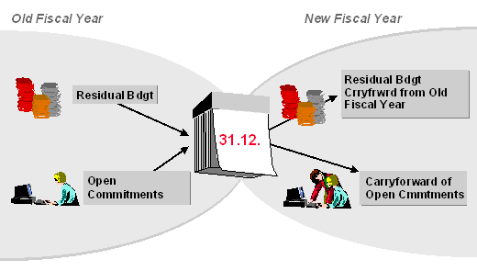
The commitment carry forward always reflects the current state of the data in the Funds Management feeder systems. However, there is no automatic link to the closing operations in other components. This means that changes made to documents in other components are not reflected in Funds Management after the closing operations have been carried out in Funds Management. For this reason, it is recommended to not to carry out Funds Management closing operations until the closing operations have been completed in the other components.

Simulate the tasks to be carried out at the fiscal year change and can schedule them for different dates, regardless of when the fiscal year actually ends. Several programs are available for completing this task for the commitment carry forward and budget carry forward.

Closing open items

Open commitment can be closed (open commitments such as purchase requisitions, purchase orders or earmarked funds) before the commitment carry forward and delete parked FI documents if amounts not consumed should be returned to the budget.

Commitment carry forward

Various selection criteria can be applied to the commitment carry forward, such as individual funds centers, particular FM account assignments, or individual documents. The definition of carry forward parameters and carry forward rules allows to exclude many value types or FM account assignments from a carry forward or to carry out account assignment changes. In general, only those documents are transferred into the fiscal year, which can be reduced by other documents. This applies to both the payment budget and to the commitment budget.

The commitment carry forward for individual documents can also be reversed.

Budget carry forward

o Budget for commitments
The budget can be carried forward into the new fiscal year, which has become available due to a commitment carry forward into the new year.

o Residual budget
By defining carry forward parameters and rules, it is possible to control residual budget carry forwards individually, thereby ensuring that changes to the organizational structure are taken into account. In the new fiscal year, the residual budget can be distributed to one or more receivers. It is also possible to carry forward partial amounts.

Commitment Item Carry Forward Payment Budget

We specify per FM area, fiscal year, and value type (such as purchase orders or invoices), and whether carrying forward commitments for the payment budget to the new fiscal year is allowed or not.

FM Area | Fiscal Year | Value Type | Carry forward Is allowed
FMDC | 2012 | 50 (P.R) | Selected
FMDC | 2012 | 51 (P.O) | Selected

BCS - Activate Budget Carry Forward for Commitment

Here, define for which value type and budget category the carry forward of budget for commitment should be activated or deactivated for each FM area/fiscal year. The settings can be defined for individual value types or for all value types that are used in the field value type

FM Area | Fiscal year | Value Type | Budget Category | Active
FMDC | 2012 | 50 (P.R) | 9H | Active
FMDC | 2012 | 51 (P.O) | 9H | Active

Frice List

DCCL requires to maintain the budgets in different formats. Forms attached. We will check the feasibility with the ABAPer in developing the forms.

Error! Not a valid link.

